Studies on BI-010 – February 2014

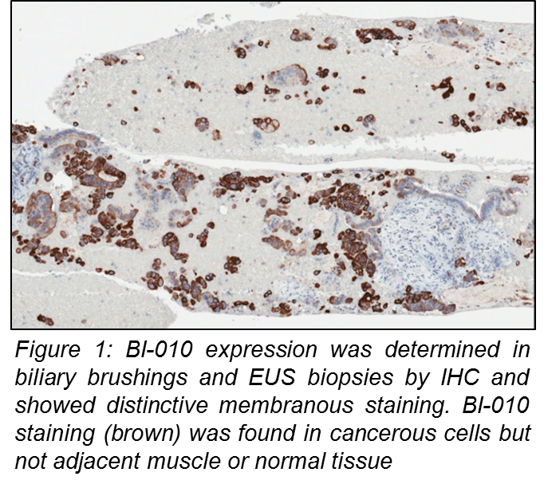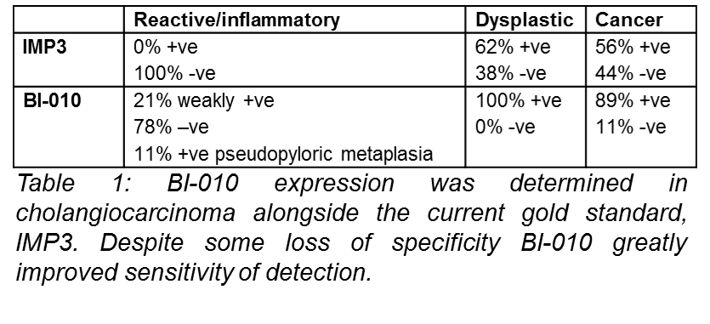Studies on BI-010 have been ongoing in our laboratory for >12 months. We have data from resected tissue and TMAs showing that BI-010 is overexpressed at the cell membrane in cholangiocarcinoma but not normal or reactive inflammatory cells often associated with this cancer type. BI-010 is also overexpressed in pancreatic tumour cells but not normal cells or chronic pancreatitis (p<0.001, sensitivity 95%, specificity 98%, PPV 99%, NPV 94%). In preliminary studies in our laboratory BI-010 showed improved sensitivity compared to the current gold standard for cholangiocarcinoma, IMP3 (89% versus 56%) (Table 1). Additional worked has tested BI-010 on diagnostic biliary brushings and EUS biopsies (Figure 1) with a view to using it together with IMP3 to improve diagnosis. Work is ongoing to get larger cohorts of patients for further analyses. Ethics has now been obtained to link our results to clinical outcome so that we can determine if BI-010 can predict those patients most likely to have a poor outcome.
Using funds from AMMF we have made recombinant BI-010 and we are using it to try and develop a test using our robust biomarker pipeline to detect BI-011 in blood, urine, bile or cyst fluid. We have linked BI-010 to cell cycle progression in Panc-1 cells. Cells with lowered BI-010 expression cannot progress through the cell cycle indicating that cancerous cells that overexpress BI-010 will divide more rapidly leading to the development of cancer.

Future work

Further validation
Although BI-010 expression has been determined in a number of patients we would like to expand this study by collaborating with other researchers at other sites to increase the size of our cohort to hundreds of patients. We have already spoken to several potential sources. Identifying where collections are located and bringing them together will provide a great resource for future studies. If consents allow we hope to combine samples into tissue microarrays which will allow us to study BI-010 and other novel markers in cholangiocarcinoma in lots of patients very quickly.

Studying the function of BI-010
Although we know that BI-010 is involved with cell cycle regulation we are still unclear about how BI-010 has this effect, how it effects the expression of other proteins to alter cell cycle and if this could be targeted for therapeutic benefit. To begin to understand the cellular function of BI-010 we would like to perform expression array studies using the stable Panc-1 cell lines we have already made. We would like to compare mRNA expression in cells with high levels of BI-010 with those where BI-010 have been greatly reduced (knocked down). To give robust data this requires a 6 replicates in each group. We have access to Bioinformatics support and pathway analysis tools so that we can fully exploit the results as quickly as possible.

Combining biomarker and genomic information
By looking at the amino acid sequence of BI-010 we have identified motifs known to be involved in regulating the expression of cell cycle proteins called a ‘KEN box’ and ‘RXXL’ motif. In other proteins an E3 ligase binds to the RXXL motif leading to ubiquitination of the lysine residue in the KEN box and ultimately degradation of the protein. This allows expression of proteins such as BI-010 to be highly regulated during the cell cycle so that cell division is controlled. In patients with a range of other cancers we have identified a number of mutations which cluster around these important motifs. Although these data were not generated in cholangiocarcinoma patients they were found in many other cancer types suggesting they will also be found in cholangiocarcinoma. Our hypothesis is that these mutations prevent BI-010 from being degraded by ubiquitin and therefore expression levels rise leading to rapid cell division and cholangiocarcinoma. We aim to test this hypothesis by mutating these key residues in BI-010 and determining the effect they have on the cell cycle using flow cytometry. This assay has already been set up in our laboratory and stable cell lines with reduced BI-010 have already been produced to allow this experiment to go ahead quickly.

Costings

Further validation
Expanding cohort and TMA production (if possible) £3000
Antibody and IHC costs £1500

Studying the function of BI-010
Expression arrays 12 arrays @£200 each £2400
qPCR validation £500

Combining biomarker and genomic information
Site directed mutagenesis kits 5@£200 each £1000
Mutagenesis primers and sequencing £1000
Antibodies and reagents for flow cytometry £1000
Total £10,400

.

